**BANNARI AMMAN INSTITUTE OF TECHNOLOGY**

**An Autonomous Institution Affiliated to Anna University - Chennai, Accredited by NAAC with A+ Grade**

**Sathyamangalam - 638401 Erode District, Tamil Nadu, India**

**Student Name:** HARI NIVASAA V

**Seat No:** 333

**Project ID:** 25

**Project title:**  **Grievance portal for anonymous and personal grievances**

**Technical Components /Component Tech Stack**

|  |  |
| --- | --- |
| Frontend | Angular |
| Backend | Node.js |
| Database | MongoDB |
| API | RESTful services |

**Implementation Timeline:**

|  |  |  |  |  |
| --- | --- | --- | --- | --- |
| **Phase** | **Deadline** | **Status** | **Notes** |  |
| **Stage 1** | **26.07.2024** | Completed | **Planning and Requirement gathering** |  |
| **Stage 2** |  | Under review | **Design and Prototyping** |  |
| **Stage 3** |  | **Not Started** | **DB Designing** |  |
| **Stage 4** |  | **Not Started** | **Backend Implementation** |  |
| **Stage 5** |  | **Not Started** | **Testing & Implementation** |  |

**PROBLEM STATEMENT:**

The college grievance portal is designed to streamline the process of addressing student concerns by allowing both anonymous and personal grievances. Students can submit issues related to academics, administration, and campus life through an intuitive web interface. The portal ensures confidentiality for anonymous grievances, fostering an environment where students feel safe to report sensitive issues. Personal grievances enable more direct follow-up and resolution. The system categorizes queries, supports role-based access for Admin, User, and Faculty Members, and integrates Google login for seamless access. This portal aims to enhance transparency, accountability, and communication within the college community.

**PROJECT-FLOW:**

**Purpose:**

The purpose of the grievance portal is to provide a secure and efficient platform for individuals to report and address their concerns. It allows users to submit both anonymous and personal grievances, ensuring that sensitive issues can be raised without fear of retaliation. The portal categorizes and routes grievances to the appropriate authorities, enabling timely and effective resolutions. By facilitating open communication and accountability, the grievance portal aims to create a safer, more transparent, and supportive environment within the organization or community.

**Scope:**

1. User Roles and Authentication
2. Grievance Submission
3. User Interface
4. Grievance Management
5. Security and Confidentiality
6. Reporting and Analytics
7. Support and Maintenance

**Consideration:**

● All users possess active Google accounts for authentication.

● Users have regular access to internet-enabled devices.

**Dependencies:**

● Integration with Google OAuth for user authentication.

● Service for sending notifications and alerts (e.g., SendGrid, Twilio).

**Functional Requirements:**

● **User Authentication:** Secure login using Google OAuth.

● **Grievance portal:** category of queries and descriptionsin personal and anonymous.

● **Conflict Resolution:** faculty will resolve the queries or they will pass to M-Team.

● **Dynamic Dashboard:** Real-time viewing of the status of grievances.

● **Removal of same queries:** the same grievances will be automatically deleted.

**Features:**

1. **User Authentication and Registration:**
   * Secure login and registration for faculty and admin users.
   * Separate dashboards tailored for faculty and admin users.
2. **Grievance Submission:**
   * Option to submit grievances either anonymously or personally.
   * Categorization of grievances for improved management.
   * Summary section to provide detailed information about the grievance.
   * Form submission to store grievances in the database.
3. **Grievance Management:**
   * Admins can view all submitted grievances.
   * Admins can categorize grievances as accepted or rejected based on their relevance.
   * Management of grievance resolution, including assigning tasks to team members.
   * Status updates and progress tracking of grievance resolution.
4. **Notification System:**
   * Automated notifications to faculty members about the status of their grievances.
   * Notifications to admins about new grievances and updates on ongoing resolutions.
5. **Report Generation:**
   * Generation of reports on grievances and their resolutions, monthly or sem-wise.
   * Analysis of grievance data to improve the resolution process.

**DATABASE INTERACTION:**

To set up database interaction in a full-stack grievance portal using Angular 18 for the frontend and Node.js with Express and MongoDB for the backend, follow these steps:

1. Initialize Node.js Project:
2. Install Dependencies:
3. Create Server File (server.js)
4. Define Mongoose Schemas and Models:
5. Use the Routes in server.js:

**FIGMA DEMO DESIGNS:**

**LOGIN PAGE DASHBOARD PAGE**

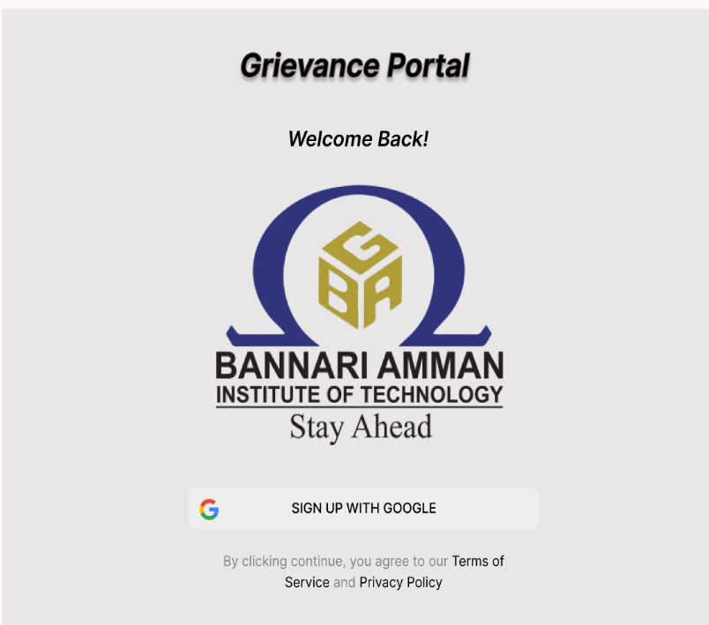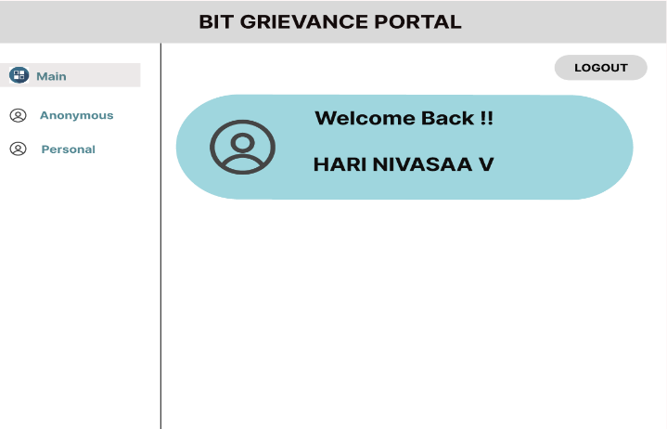

**ANONYMOUS PORTAL PERSONAL PORTAL AND LOGOUT**

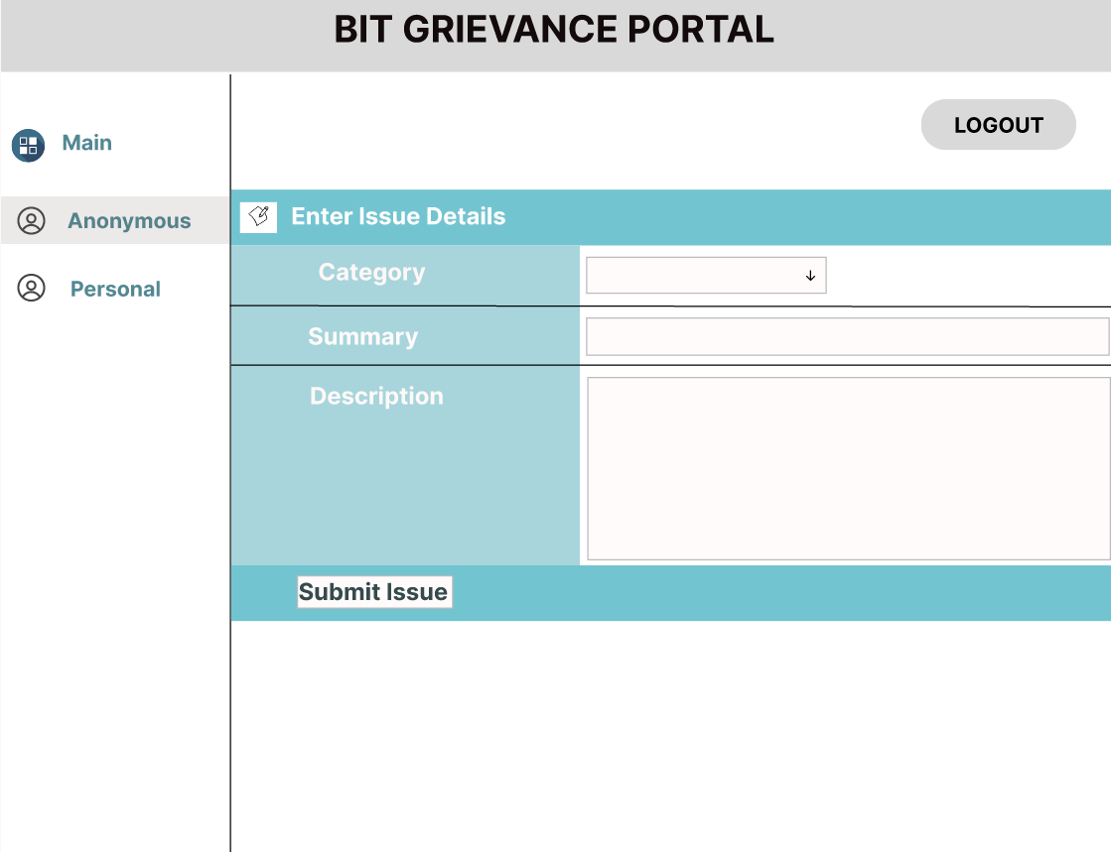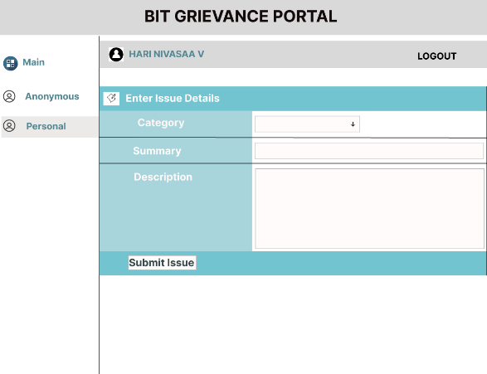

**FLOW CHART: ER DIAGRAM (DB DESIGN):**

